Table of Contents

Contents

**Chapter I: Introduction** 2

1.1 Background 2

1.2 Introduction of Project 3

1.3 Current situation/Problem of the organization 3

1.4 Objective 3

1.5 Methodology Development Model 4

1.6 Tools and Technique 5

**Chapter II: Task and Activities Performed** 16

2.1 Problems 16

2.2 Existing System 16

2.3 Improvement 16

2.4 Coding 17

2.5 Screen Short 19

**Chapter III: Discussion and Conclusion** 22

3.1 Conclusion 22

# **Chapter I: Introduction**

## 1.1 Background

Tribhuvan University, Faculty of Management (FOM) initiated Bachelor in Information Management (BIM) program to produce the competent students with blend of both theoretical knowledge and practical exposure. In order to make BIM a complete package progressive study two weeks of project in related field would certainly boost up the performance of students in real world to develop socially responsive and creative and result oriented management professionals.

The program aims to prepare knowledgeable, skillful and confident and self-motivated professionals who will be able to perform their job competitively in organizations of modern business world. Summer project is a method by which the students get an opportunity to experience the real work environment through indulgence into real task accomplishment where they learn by doing things. The major objectives of this summer project is to acquaint students with corporate world and involve in practical decisions and actions and observe the relevance of theories in practices as well as closely experience the organization realities.

The students of BIM program under Tribhuvan University are required to prepare an summer project report based on their experience and findings in organization on their sixth semester. Being the students of BIM we have selected to work as project in KIST COLLEGE, HOSTEL MANAGEMENT SYSTEM. This summer project report provides the glimpse about the experience working on the college management system of Kist College.

## 1.2 Introduction of Project

Hostel Management System is a Software development for managing various activities of the hostel. The Software help user in case of Hostel Information, registration, room and Searching Hostel Account. Aim of the Hostel Management System is to manage the records and make user friendly Software. It helps admin to manage student records, Staff Records and many more. Due to the increase in educational institution Hostel are also increasing for the accommodation.

Hostel management System is online application developed for managing various activities of the hostel. Deals with the problem on managing the hostel and avoided the problem which occur when carried out manually.

## 1.3 Current situation/Problem of the organization

All the People who wants to book, see the rooms, wants some of the details about hostel, its facilities and many more .The need to visit themselves. If there is some mistake while recording the information that will take long time to correct it. Sometime records may be destroyed .

## 

## 1.4 Objective

* Provide quick and efficient means for gathering the student information along with their rooms, course, contact, check-in and check-out.
* Maintaining Employee Records.
* Secure all the data of the Hosteller

## 1.5 Methodology Development Model

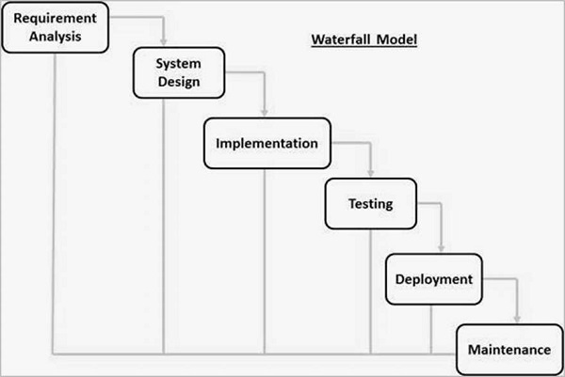

The sequential phases in Waterfall model are −

**Requirement Gathering and analysis** − All possible requirements of the system to be developed are captured in this phase and documented in a requirement specification document.

* **System Design** − The requirement specifications from first phase are studied in this phase and the system design is prepared. This system design helps in specifying hardware and system requirements and helps in defining the overall system architecture.
* **Implementation** − With inputs from the system design, the system is first developed in small programs called units, which are integrated in the next phase. Each unit is developed and tested for its functionality, which is referred to as Unit Testing.
* **Integration and Testing** − All the units developed in the implementation phase are integrated into a system after testing of each unit. Post integration the entire system is tested for any faults and failures.
* **Deployment of system** − Once the functional and non-functional testing is done; the product is deployed in the customer environment or released into the market.
* **Maintenance** − There are some issues which come up in the client environment. To fix those issues, patches are released. Also to enhance the product some better versions are released. Maintenance is done to deliver these changes in the customer environment.

## 1.6 Tools and Technique

1. Php
2. Xampp
3. Mysql yog
4. HTML
5. Bootstrap
6. Sublime text
7. Git hub
8. Java Script
9. Css

Php

**Hypertext Preprocessor** (or simply **PHP**) is a [server-side scripting](https://en.wikipedia.org/wiki/Server-side_scripting) language designed for [Web development](https://en.wikipedia.org/wiki/Web_development), but also used as a [general-purpose programming language](https://en.wikipedia.org/wiki/General-purpose_programming_language). It was originally created by [Rasmus Lerdorf](https://en.wikipedia.org/wiki/Rasmus_Lerdorf) in 1994,[]](https://en.wikipedia.org/wiki/PHP#cite_note-History_of_PHP-5) the PHP [reference implementation](https://en.wikipedia.org/wiki/Reference_implementation) is now produced *by* The PHP Group. PHP originally stood for Personal *Home Page*,[]](https://en.wikipedia.org/wiki/PHP#cite_note-History_of_PHP-5) but it now stands for the [recursive acronym](https://en.wikipedia.org/wiki/Recursive_acronym) *PHP: Hypertext Preprocessor*.

PHP code may be embedded into [HTML](https://en.wikipedia.org/wiki/HTML) code, or it can be used in combination with various [web template systems](https://en.wikipedia.org/wiki/Web_template_system), web content management systems, and [web frameworks](https://en.wikipedia.org/wiki/Web_framework). PHP code is usually processed by a PHP [interpreter](https://en.wikipedia.org/wiki/Interpreter_(computing)) implemented as a [module](https://en.wikipedia.org/wiki/Plugin_(computing)) in the web server or as a [Common Gateway Interface](https://en.wikipedia.org/wiki/Common_Gateway_Interface) (CGI) executable. The web server combines the results of the interpreted and executed PHP code, which may be any type of data, including images, with the generated web page. PHP code may also be executed with a [command-line interface](https://en.wikipedia.org/wiki/Command-line_interface) (CLI) and can be used to implement [standalone](https://en.wikipedia.org/wiki/Computer_software) [graphical applications](https://en.wikipedia.org/wiki/Graphical_user_interface).

Xampp

XAMPP is a [free and open source](https://en.wikipedia.org/wiki/Free_software) [cross-platform](https://en.wikipedia.org/wiki/Cross-platform) [web server](https://en.wikipedia.org/wiki/Web_server) [solution stack](https://en.wikipedia.org/wiki/Solution_stack) package developed by Apache Friends, consisting mainly of the [Apache HTTP Server](https://en.wikipedia.org/wiki/Apache_HTTP_Server), [MariaDB](https://en.wikipedia.org/wiki/MariaDB) [database](https://en.wikipedia.org/wiki/Database), and [interpreters](https://en.wikipedia.org/wiki/Interpreter_(computing)) for scripts written in the [PHP](https://en.wikipedia.org/wiki/PHP) and [Perl](https://en.wikipedia.org/wiki/Perl) [programming languages](https://en.wikipedia.org/wiki/Programming_language). XAMPP stands for Cross-Platform (X), Apache (A), MariaDB (M), PHP (P) and Perl (P). It is a simple, lightweight Apache distribution that makes it extremely easy for developers to create a local web server for testing and deployment purposes. Everything needed to set up a web server – server application (Apache), database (MariaDB), and scripting language (PHP) – is included in an extractable file. XAMPP is also cross-platform, which means it works equally well on Linux, Mac and Windows. Since most actual web server deployments use the same components as XAMPP, it makes transitioning from a local test server to a live server extremely easy as well.

Mysql yog

MySQL Workbench is a unified visual tool for database architects, developers, and DBAs. MySQL Workbench provides data modeling, SQL development, and comprehensive administration tools for server configuration, user administration, backup, and much more. MySQL Workbench is available on Windows, Linux and Mac OS X.

HTML

Hypertext Markup Language (HTML) is the standard [markup language](https://en.wikipedia.org/wiki/Markup_language) for creating [web pages](https://en.wikipedia.org/wiki/Web_page) and [web applications](https://en.wikipedia.org/wiki/Web_application). With [Cascading Style Sheets](https://en.wikipedia.org/wiki/Cascading_Style_Sheets) (CSS) and [JavaScript](https://en.wikipedia.org/wiki/JavaScript), it forms a triad of cornerstone technologies for the [World Wide Web](https://en.wikipedia.org/wiki/World_Wide_Web).[[4]](https://en.wikipedia.org/wiki/HTML#cite_note-4)

[Web browsers](https://en.wikipedia.org/wiki/Web_browser) receive HTML documents from a [web server](https://en.wikipedia.org/wiki/Web_server) or from local storage and [render](https://en.wikipedia.org/wiki/Browser_engine) the documents into multimedia web pages. HTML describes the structure of a web page [semantically](https://en.wikipedia.org/wiki/Semantic_Web) and originally included cues for the appearance of the document.

[HTML elements](https://en.wikipedia.org/wiki/HTML_element) are the building blocks of HTML pages. With HTML constructs, [images](https://en.wikipedia.org/wiki/HTML_element#Images_and_objects) and other objects such as [interactive forms](https://en.wikipedia.org/wiki/Fieldset) may be embedded into the rendered page. HTML provides a means to create [structured documents](https://en.wikipedia.org/wiki/Structured_document) by denoting structural [semantics](https://en.wikipedia.org/wiki/Semantics) for text such as headings, paragraphs, lists, [links](https://en.wikipedia.org/wiki/Hyperlink), quotes and other items.

Bootstrap

Bootstrap is a [free and open-source](https://en.wikipedia.org/wiki/Free_and_open-source_software) front-end framework for designing [websites](https://en.wikipedia.org/wiki/Website) and [web applications](https://en.wikipedia.org/wiki/Web_application). It contains [HTML](https://en.wikipedia.org/wiki/HTML)- and [CSS](https://en.wikipedia.org/wiki/CSS)-based design templates for [typography](https://en.wikipedia.org/wiki/Typography), forms, buttons, navigation and other interface components, as well as optional [JavaScript](https://en.wikipedia.org/wiki/JavaScript) extensions. Unlike many web frameworks, it concerns itself with [front-end development](https://en.wikipedia.org/wiki/Front-end_web_development) only.

Java Script

JavaScript  often abbreviated as JS, is a [high-level](https://en.wikipedia.org/wiki/High-level_programming_language), [interpreted](https://en.wikipedia.org/wiki/Interpreted_language) [programming language](https://en.wikipedia.org/wiki/Programming_language). It is a language which is also characterized as [dynamic](https://en.wikipedia.org/wiki/Dynamic_programming_language), [weakly typed](https://en.wikipedia.org/wiki/Weak_typing), [prototype-based](https://en.wikipedia.org/wiki/Prototype-based_programming) and [multi-paradigm](https://en.wikipedia.org/wiki/Multi-paradigm_programming_language).

Alongside [HTML](https://en.wikipedia.org/wiki/HTML) and [CSS](https://en.wikipedia.org/wiki/CSS), JavaScript is one of the three core technologies of the [World Wide Web](https://en.wikipedia.org/wiki/World_Wide_Web). JavaScript enables interactive [web pages](https://en.wikipedia.org/wiki/Web_page) and thus is an essential part of [web applications](https://en.wikipedia.org/wiki/Web_application). The vast majority of [websites](https://en.wikipedia.org/wiki/Website) use it, and all major [web browsers](https://en.wikipedia.org/wiki/Web_browser) have a dedicated [JavaScript engine](https://en.wikipedia.org/wiki/JavaScript_engine) to execute it.

Sublime Text

Sublime Text is a [proprietary](https://en.wikipedia.org/wiki/Proprietary_software) [cross-platform](https://en.wikipedia.org/wiki/Cross-platform) [source code editor](https://en.wikipedia.org/wiki/Source_code_editor) with a [Python](https://en.wikipedia.org/wiki/Python_(programming_language)) [application programming interface](https://en.wikipedia.org/wiki/Application_programming_interface) (API). It natively supports many [programming languages](https://en.wikipedia.org/wiki/Programming_languages) and [markup languages](https://en.wikipedia.org/wiki/Markup_languages), and functions can be added by users with [plugins](https://en.wikipedia.org/wiki/Plugins), typically community-built and maintained under [free-software licenses](https://en.wikipedia.org/wiki/Free_software_licenses).

Github

GitHub is a web-based [hosting service](https://en.wikipedia.org/wiki/Internet_hosting_service) for [version control](https://en.wikipedia.org/wiki/Version_control) using [Git](https://en.wikipedia.org/wiki/Git). It is mostly used for [computer code](https://en.wikipedia.org/wiki/Source_code). It offers all of the [distributed version control](https://en.wikipedia.org/wiki/Distributed_version_control) and [source code management](https://en.wikipedia.org/wiki/Source_code_management) (SCM) functionality of Git as well as adding its own features. It provides [access control](https://en.wikipedia.org/wiki/Access_control) and several collaboration features such as [bug tracking](https://en.wikipedia.org/wiki/Bug_tracking_system), [feature requests](https://en.wikipedia.org/wiki/Software_feature), [task management](https://en.wikipedia.org/wiki/Task_management), and [wikis](https://en.wikipedia.org/wiki/Wiki) for every project.

GitHub offers plans for both private repositories and free accounts which are commonly used to host [open-source](https://en.wikipedia.org/wiki/Open-source) software projects.

Css

Cascading Style Sheets (CSS) is a [style sheet language](https://en.wikipedia.org/wiki/Style_sheet_language) used for describing the [presentation](https://en.wikipedia.org/wiki/Presentation_semantics) of a document written in a [markup language](https://en.wikipedia.org/wiki/Markup_language) like [HTML](https://en.wikipedia.org/wiki/HTML). CSS is a cornerstone technology of the [World Wide Web](https://en.wikipedia.org/wiki/World_Wide_Web), alongside HTML and [JavaScript](https://en.wikipedia.org/wiki/JavaScript).

CSS is designed to enable the separation of presentation and content, including [layout](https://en.wikipedia.org/wiki/Page_layout), [colors](https://en.wikipedia.org/wiki/Color), and [fonts](https://en.wikipedia.org/wiki/Typeface). This separation can improve content [accessibility](https://en.wikipedia.org/wiki/Accessibility), provide more flexibility and control in the specification of presentation characteristics, enable multiple [web pages](https://en.wikipedia.org/wiki/Web_page) to share formatting by specifying the relevant CSS in a separate css file, and reduce complexity and repetition in the structural content.

1.7 Specification Requirement

External Interfaces

- This interface will be actual interface through which the user will communication with the application and perform the desired tasks.

Admin login

**I.D:**

**Role**: Admin wishes to login to the system

**Precondition**: Username and Password

**Success end Condition**: Main option of screen display

**Failed end Condition**: User has entered incorrect Username and

Password or both

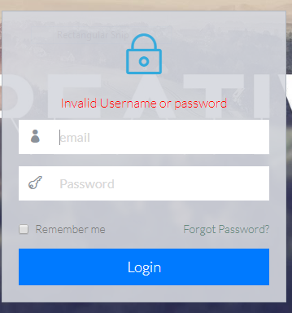

Edit

**ID:**

**Precondition:** User has successfully navigated to the

search result

**Success end Condition:** User has successfully made the

changes

**Failed end Condition:** No room details is available

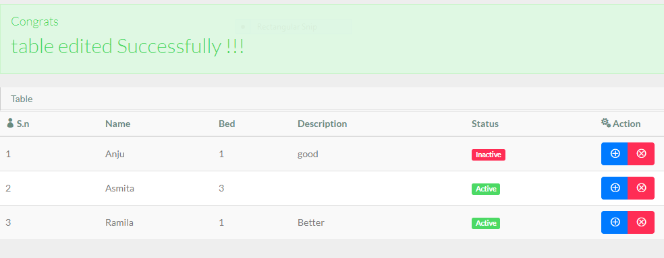

1.To edit room records in the data base, first search the record you want to edit then click on ‘+’ button.

2.Edit the particulars of the room that you want to change and click on’ Save’ button.

Software Product Features

1Hostel management System

Login Information System

* Description

-The system will maintain the login information of its user to enter in to the software

* Validating Checks

-Administrator need to login the unique id and password.

-Contact number should have maximum 10 digits.

-All the details must be fill up.

-Email address should be in the proper format.

* Sequencing information

-Login information should be filled before the user allowed to choose from the option such as Details, Facilities, Room Details, and Booking.

* Error Handling

-If user doesn’t filled up validate information then the system display error message for user and request to enter the validate information.

2.2.2Employee information System

* Description

-The system will maintain employee information including employee id, name, Address, Contact, Working time and Salary.

* Validity Checks

-Employee Address should not be incorrect.

-Employee id cannot be NULL.

-Employee Salary cannot be NULL.

* Sequencing Information

-Employee information is filled before the employee will join the work.

* Error Handling

-If the employee NULL the id and Salary then the System display error until the employee information are filled

Student Information

* Description

-The System will maintain the student details such as Parents name, Contact number and department.

* Validity Check

-Student parent name and contact must be fill up. Student Department should not be NULL.

* Sequencing information

-Student Information should be filled at the same time when the registration information are been filled.

* Error Handling

-Validate information should be filled.

Performance required

* Security

-System should be Protected from unauthorized access Where the validate Username and Password are required so no other can access.

* Maintainability

-System should be design in a maintain order. So it can be easily modified.

Logical Database

|  |  |  |
| --- | --- | --- |
| Sno. | Entity | Attribute |
| 1 | Admin | * Id * First name * Last name * Email * Contact * Password * Role * Status |
| 2 | Room | * Room id * Name * Bed * Status * Description |
| 3 | Student | * Student Id * Student Name * Parents Name * Parents Contact * Department * year * Room * Status |
| 4 | User | * User Id * User name * User password * Email * Contact * Gender |

3.Data Design

3.1 Data Model: A database model is a type of data model that determines the logical structure of a database and fundamentally determines in which manner data can be stored, organized and manipulated.

Level 0

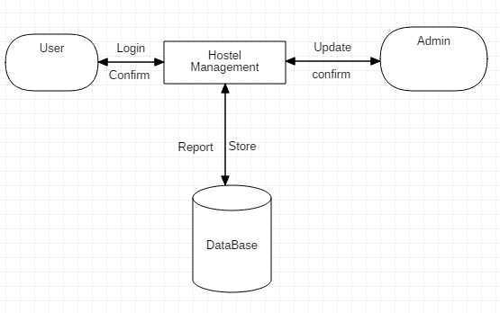

Figure: Data flow

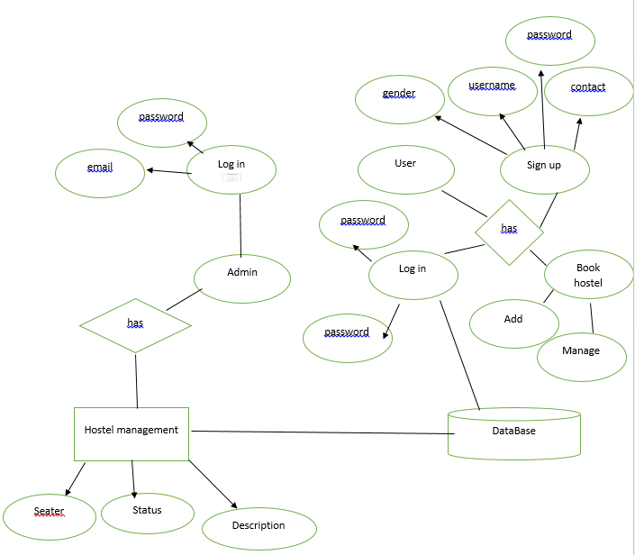

Figure:ER diagram

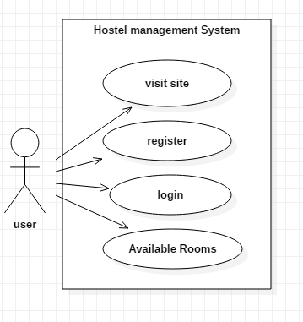

Figure: Use case Diagram of Hostel Management System

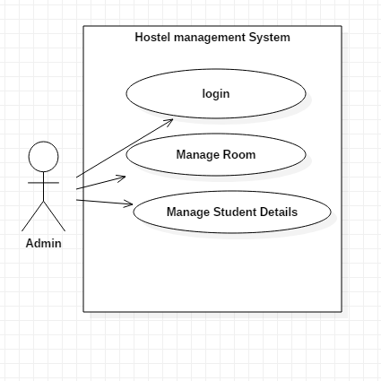

Figure: Use case Diagram of Hostel Management System

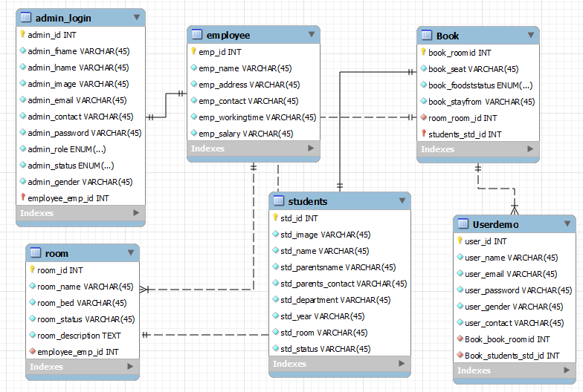

## Figure: Schema Diagram

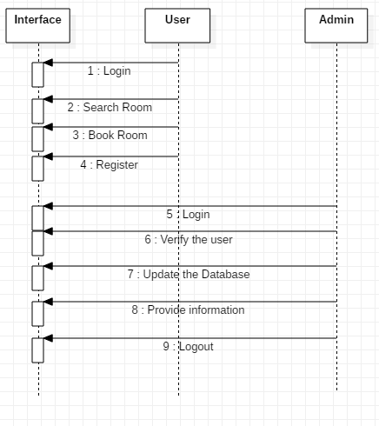

Figure: Sequence Diagram

# 

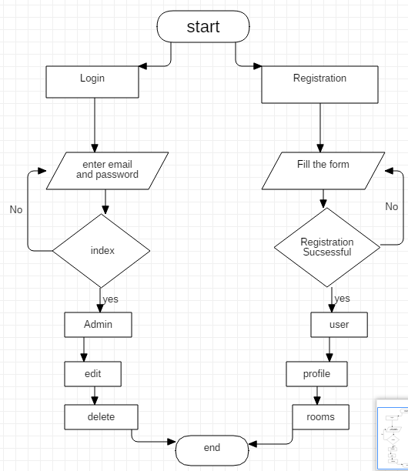

Figure: Flowchart of Hostel Management System

# 

## Table 2: Test Case

# **Chapter II: Task and Activities Performed**

## 2.1 Problems

* Data store on the Paper may be lost, Stolen or destroyed due to natural calamity.
* Time consuming Process.
* Chances of Human error.
* Lack of Security.
* High Cost of Maintenance.
* Updating Process

## 2.2 Existing System

* Difficult to maintain or update records all the records
* Time consuming.
* Inaccuracy data.
* Updating process

## 2.3 Improvement

* Reduce the cost maintenance.
* Make present Manual System more interactive, Speedy and User Friendly.
* Provide Quick response.
* Avail Information When ever needed.
* Highly Security.
* Easy to handle, Update and keep record.
* Backup data are easily generated.

## 2.4 Coding

Call.php

<?php

include'config.php';

include'connect.php';

include 'helperfunction.php';

include 'adminfunctions.php';

include 'roomfunction.php';

include 'studentfunction.php';

include 'userfunction.php';

Config.php

<?php

define('SERVER','localhost');

define('DBUSER','root');

define('DBPASS','');

define('DBNAME', 'summerproject');

Connect.php

<?php

$servername=SERVER;

$dbname=DBNAME;

try {

$conn = new PDO("mysql:host=$servername;dbname=$dbname", DBUSER, DBPASS);

// set the PDO error mode to exception

$conn->setAttribute(PDO::ATTR_ERRMODE, PDO::ERRMODE_EXCEPTION);

// echo "Database created successfully<br>";

}

catch(PDOException $e)

{

echo $sql . "<br>" . $e->getMessage();

}

## 2.5 Screen Short

2.4.1 Admin index

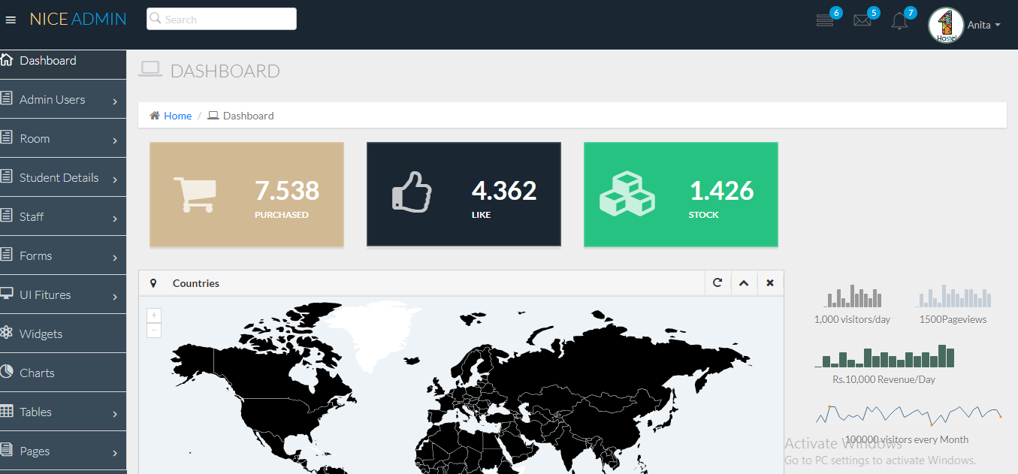

2.4.2 User Registration

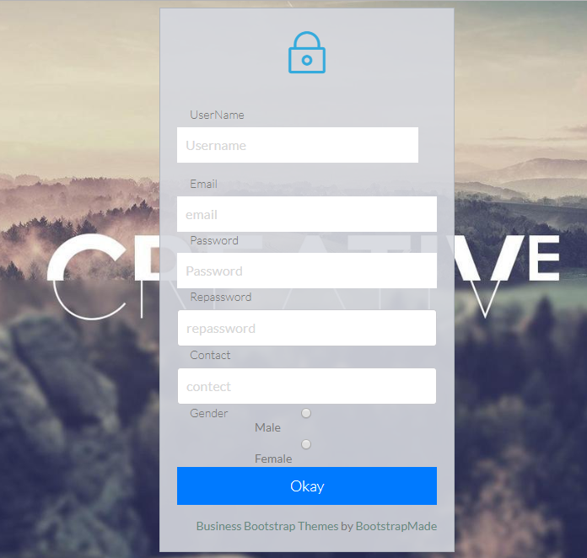

2.4.3 User Index

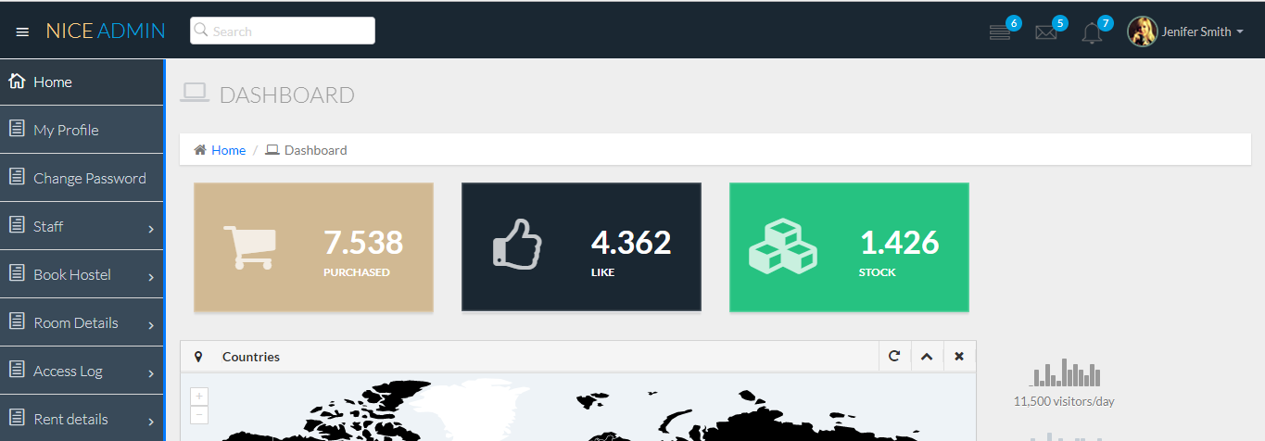

## 

# **Chapter III: Discussion and Conclusion**

## 3.1 Conclusion

To conclude the description about the project : The project, developed using PHP and MySQL is based on the requirement specification of the user and the analysis of the existing system, with flexibility for future enhancement. The expanded functionality of today’s software requires an appropriate approach towards software development. This hostel management software is designed for people who want to manage various activities in the hostel. For the past few years the number of educational institutions are increasing rapidly. Thereby the number of hostels are also increasing for the accommodation of the students studying in this institution. And hence there is a lot of strain on the person who are running the hostel and software’s are not usually used in this context. This particular project deals with the problems on managing a hostel and avoids the problems which occur when carried manually. Identification of the drawbacks of the existing system leads to the designing of computerized system that will be compatible to the existing system with the system which is more user friendly

## References:

* [**http://www.tutorialspoint.com**](http://www.tutorialspoint.com)
* **https://www.w3schools.com/**
* [**https://www.cloudbeds.com/lp/hostels-with-video/?opti_ca=868359737&opti_ag=46331462085&opti_ad=256248026129&opti_key=kwd-327038592466&utm_source=google&utm_medium=cpc&utm_campaign=hostel&utm_term=%2Bhostel%20%2Bmanagement%20%2Bsystem&gclid=EAIaIQobChMIy-W0l7KZ3QIVAR4rCh2RXwBGEAAYASAAEgIooPD_BwE**](https://www.cloudbeds.com/lp/hostels-with-video/?opti_ca=868359737&opti_ag=46331462085&opti_ad=256248026129&opti_key=kwd-327038592466&utm_source=google&utm_medium=cpc&utm_campaign=hostel&utm_term=%2Bhostel%20%2Bmanagement%20%2Bsystem&gclid=EAIaIQobChMIy-W0l7KZ3QIVAR4rCh2RXwBGEAAYASAAEgIooPD_BwE)
* **https://airbrake.io/blog/sdlc/waterfall-model**